BCE Calendar
# Source: AI Source: Provided by: [Data Path: Persons Table -> ID Column: 1, Name_En Column: Motasem Essam] -> From: [ChatGPT] on [7/17/2026]
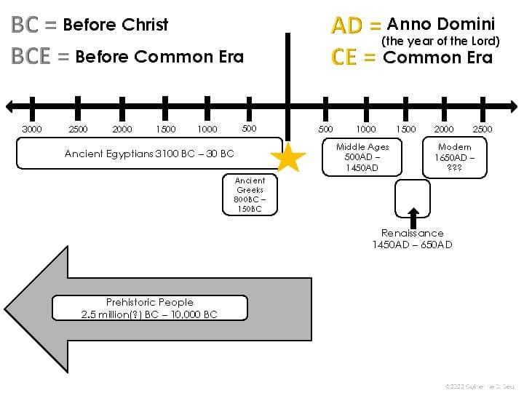
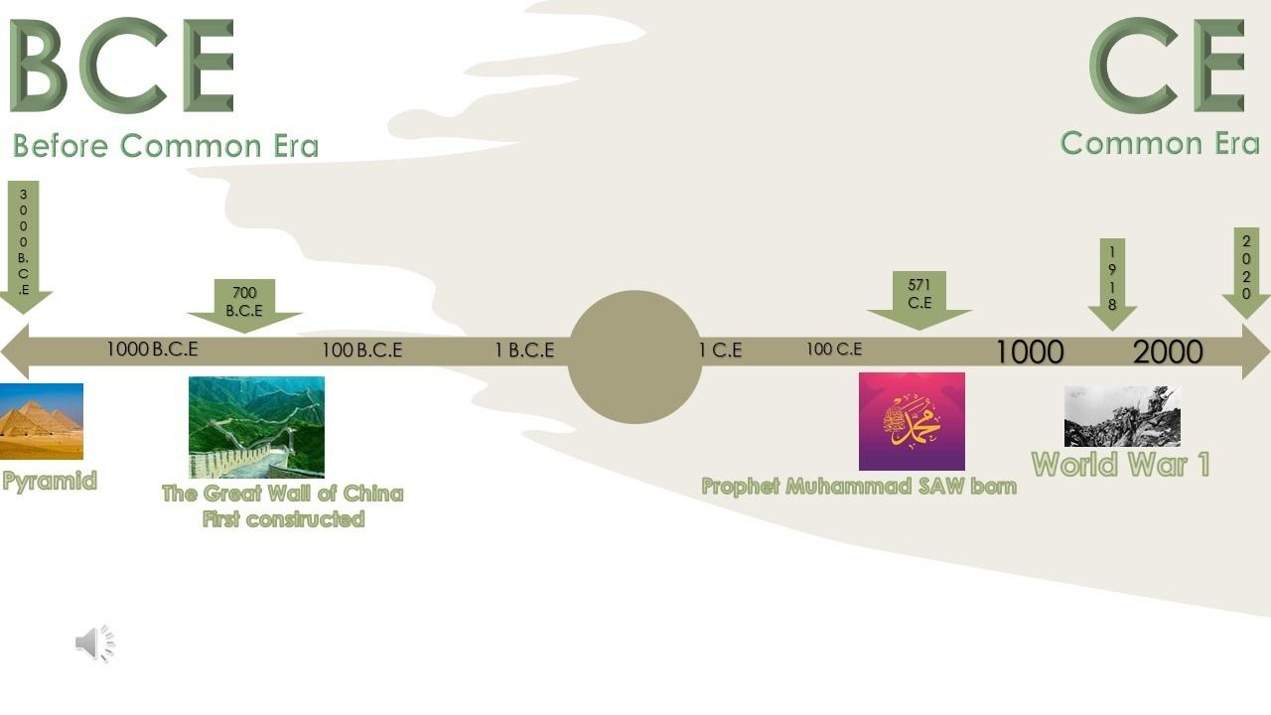
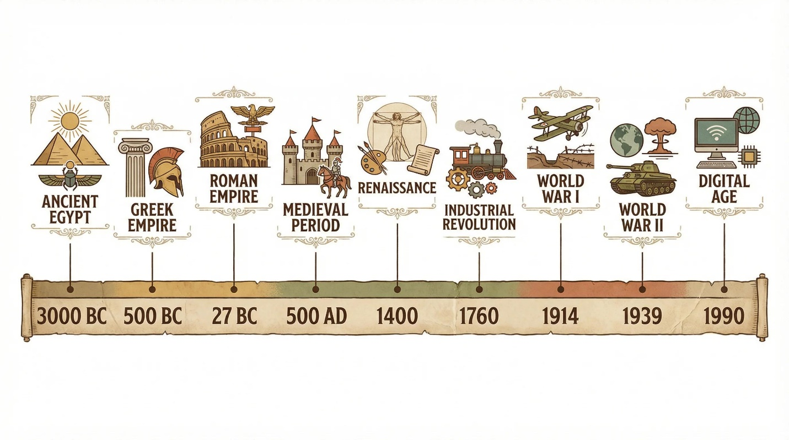
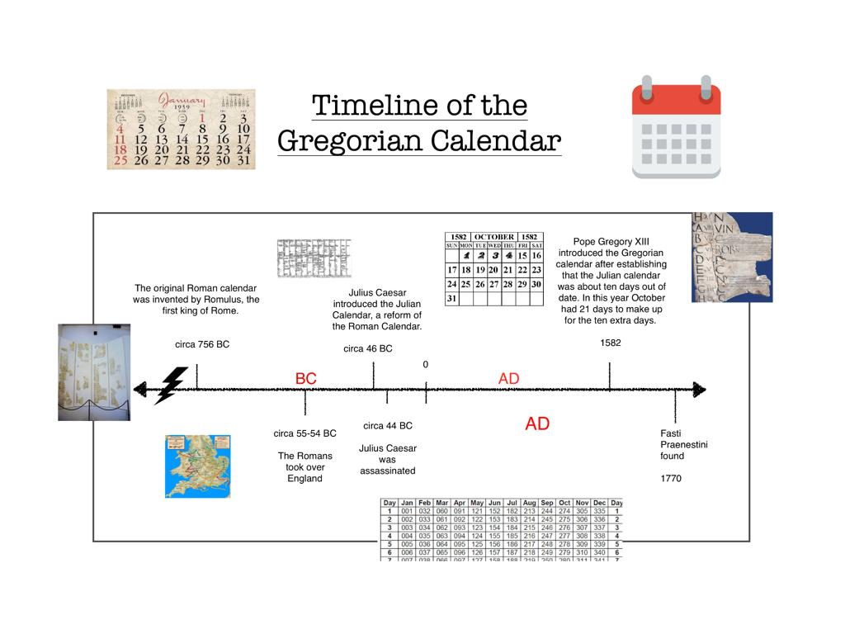
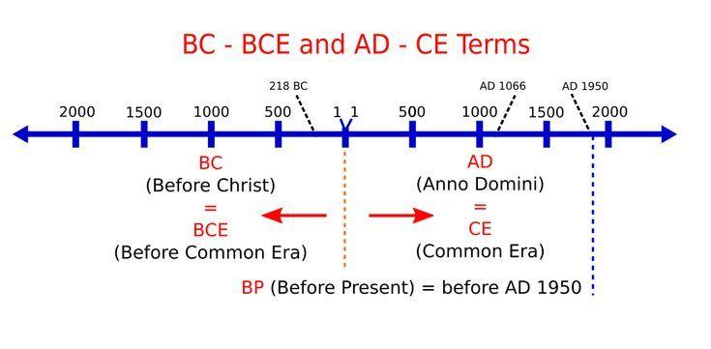
The BCE Calendar (Before Common Era) is the modern, secular year-numbering system used to designate years before the Common Era. It is numerically identical to the traditional BC (Before Christ) system but replaces the religious terminology with neutral language.
Today, BCE is widely used in:
- History
- Archaeology
- Anthropology
- Science
- Museums
- Academic publications
- International organizations

Definition
# Source: AI Source: Provided by: [Data Path: Persons Table -> ID Column: 1, Name_En Column: Motasem Essam] -> From: [ChatGPT] on [7/17/2026]
BCE (Before Common Era) is the secular designation for years that occurred before the beginning of the Common Era (CE), using the same year numbering as the traditional BC system.

Meaning of BCE
# Source: AI Source: Provided by: [Data Path: Persons Table -> ID Column: 1, Name_En Column: Motasem Essam] -> From: [ChatGPT] on [7/17/2026]
BCE stands for:
Before Common Era
It is paired with:
CE — Common Era
Together they replace the traditional terms:

Traditional | Modern Equivalent
BC | BCE
AD | CE
The year numbers remain exactly the same.

Historical Background
# Source: AI Source: Provided by: [Data Path: Persons Table -> ID Column: 1, Name_En Column: Motasem Essam] -> From: [ChatGPT] on [7/17/2026]
The BCE/CE terminology became increasingly common from the 18th century onward, especially in scholarly writing.
Its purpose is to:
- Provide religiously neutral terminology.
- Maintain the same chronological system used in the Gregorian Calendar.
- Support communication in multicultural and international contexts.

How the BCE Calendar Works
# Source: AI Source: Provided by: [Data Path: Persons Table -> ID Column: 1, Name_En Column: Motasem Essam] -> From: [ChatGPT] on [7/17/2026]
BCE years count backward toward the beginning of the Common Era.
Example sequence:
500 BCE → 300 BCE → 100 BCE → 10 BCE → 2 BCE → 1 BCE → 1 CE → 2 CE
Notice:
- There is no Year 0.

No Year Zero
# Source: AI Source: Provided by: [Data Path: Persons Table -> ID Column: 1, Name_En Column: Motasem Essam] -> From: [ChatGPT] on [7/17/2026]
The BCE/CE system moves directly from:
- 1 BCE
- 1 CE
There is no Year 0, just as in the traditional BC/AD system.

Relationship to BC
# Source: AI Source: Provided by: [Data Path: Persons Table -> ID Column: 1, Name_En Column: Motasem Essam] -> From: [ChatGPT] on [7/17/2026]
BCE uses the same year numbers as BC.
Examples:
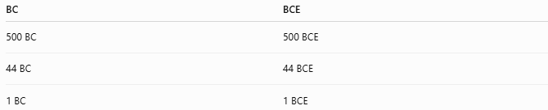
BC | BCE
500 BC | 500 BCE
44 BC | 44 BCE
1 BC | 1 BCE
Only the terminology changes.

Calendar Used
# Source: AI Source: Provided by: [Data Path: Persons Table -> ID Column: 1, Name_En Column: Motasem Essam] -> From: [ChatGPT] on [7/17/2026]
BCE year numbering is primarily used with the:
- Gregorian Calendar
It may also be applied when discussing dates in the Julian Calendar, provided the calendar is clearly identified.

Applications
# Source: AI Source: Provided by: [Data Path: Persons Table -> ID Column: 1, Name_En Column: Motasem Essam] -> From: [ChatGPT] on [7/17/2026]
The BCE system is commonly used in:
- History textbooks
- Archaeology
- Anthropology
- Museums
- Academic journals
- Scientific publications
- International organizations

Examples
# Source: AI Source: Provided by: [Data Path: Persons Table -> ID Column: 1, Name_En Column: Motasem Essam] -> From: [ChatGPT] on [7/17/2026]
Examples of well-known BCE dates:
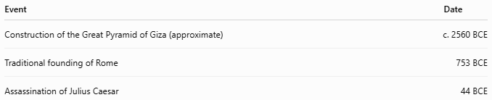
Event | Date
Construction of the Great Pyramid of Giza (approximate) | c. 2560 BCE
Traditional founding of Rome | 753 BCE
Assassination of Julius Caesar | 44 BCE

Advantages
# Source: AI Source: Provided by: [Data Path: Persons Table -> ID Column: 1, Name_En Column: Motasem Essam] -> From: [ChatGPT] on [7/17/2026]
The BCE system:
- Uses neutral terminology.
- Maintains compatibility with BC/AD year numbering.
- Is widely accepted in academic and international settings.
- Allows consistent historical dating across cultures.

Limitations
# Source: AI Source: Provided by: [Data Path: Persons Table -> ID Column: 1, Name_En Column: Motasem Essam] -> From: [ChatGPT] on [7/17/2026]
- Some historical and religious publications continue to use BC/AD.
- Readers unfamiliar with BCE/CE may initially confuse the abbreviations.

Common Mistakes
# Source: AI Source: Provided by: [Data Path: Persons Table -> ID Column: 1, Name_En Column: Motasem Essam] -> From: [ChatGPT] on [7/17/2026]
- Thinking BCE uses different year numbers than BC.
It does not.
- Assuming there is a Year 0.
- Believing BCE represents a different calendar.
It uses the same Gregorian (or, historically, Julian) calendar year numbering.

Interesting Facts
# Source: AI Source: Provided by: [Data Path: Persons Table -> ID Column: 1, Name_En Column: Motasem Essam] -> From: [ChatGPT] on [7/17/2026]
- BCE and BC refer to the same years.
- Many universities, museums, encyclopedias, and scientific journals now use BCE/CE as their standard notation.
- Switching from BC to BCE changes only the label, not the chronology.

Comparison with Other Year Numbering Systems
# Source: AI Source: Provided by: [Data Path: Persons Table -> ID Column: 1, Name_En Column: Motasem Essam] -> From: [ChatGPT] on [7/17/2026]
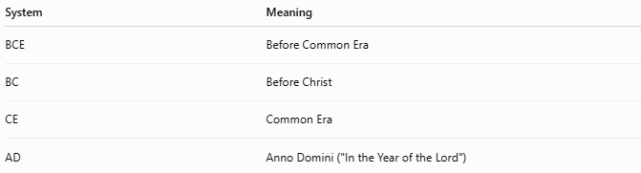
System | Meaning
BCE | Before Common Era
BC | Before Christ
CE | Common Era
AD | Anno Domini ("In the Year of the Lord")

Key Points
# Source: AI Source: Provided by: [Data Path: Persons Table -> ID Column: 1, Name_En Column: Motasem Essam] -> From: [ChatGPT] on [7/17/2026]
- BCE stands for Before Common Era.
- It uses the same year numbers as BC.
- BCE years count backward toward 1 CE.
- There is no Year 0.
- BCE is widely used in academic, historical, scientific, and international contexts.

Conclusion
# Source: AI Source: Provided by: [Data Path: Persons Table -> ID Column: 1, Name_En Column: Motasem Essam] -> From: [ChatGPT] on [7/17/2026]
The BCE Calendar (Before Common Era) is the modern, secular system for numbering years before the beginning of the Common Era. It is numerically identical to the traditional BC (Before Christ) system and differs only in terminology. By using neutral language while preserving the same chronology, the BCE/CE system provides an inclusive and internationally accepted method for expressing historical dates across cultures, disciplines, and educational settings.

